Hoffman, Naum
V00927502
STAT 260 Assignment 1

A1/A2)
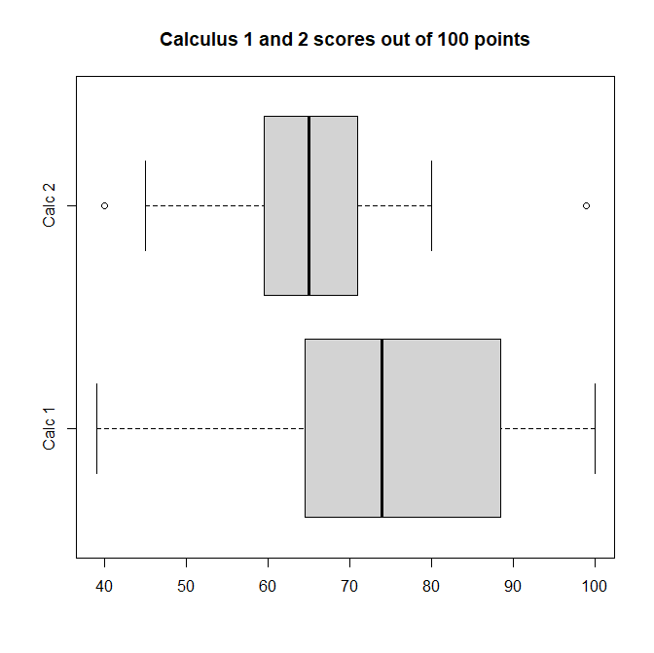
Relevant commands:
cal.1.scores = c(66, 65, 80, 66, 73, 94, 100, 93, 79, 89, 64, 90, 63, 88, 85, 67, 77, 82, 82, 39, 100, 82, 60, 56, 66, 72, 74, 67, 87, 61, 50, 58, 66, 100, 93, 92, 60, 74, 59, 94)
cal.2.scores = c(74, 77, 64, 63, 59, 69, 72, 57, 64, 55, 69, 40, 60, 54, 80, 45, 58, 60, 65, 71, 60, 61, 66, 74, 68, 71, 73, 99, 66, 63, 69, 69, 75, 47, 50)
boxplot(cal.1.scores, cal.2.scores, names = c("Calc 1", "Calc 2"), main = "Calculus 1 and 2 scores out of 100 points", horizontal=TRUE)

C)
mean(cal.1.scores)
[1] 75.325
sd(cal.1.scores)
[1] 15.07313

mean(cal.2.scores)
[1] 64.77143
sd(cal.2.scores)
[1] 10.9681

d)
Although we have less data for the calculus 2 class, I believe that the calculus 1 class did better. The mean and median of the calculus 1 class is significantly greater than the calc 2 class. In fact, the bottom quartile of calculus 1 scores is just slightly less than the median of calc 2 scores. The calculus 1 maximum is 100 and not an outlier, while the student who scored 99 on the calculus 2 test in an outlier, as well as a max. Finally, when calculating the coefficient of variation between calculus 1 and calculus 2 scores, the calculus 2 data is more spread out. This might be because the content was difficult, causing a rift in understanding of the material. Regardless, the calculus 1 students overall did significantly better than the calculus 2 students.

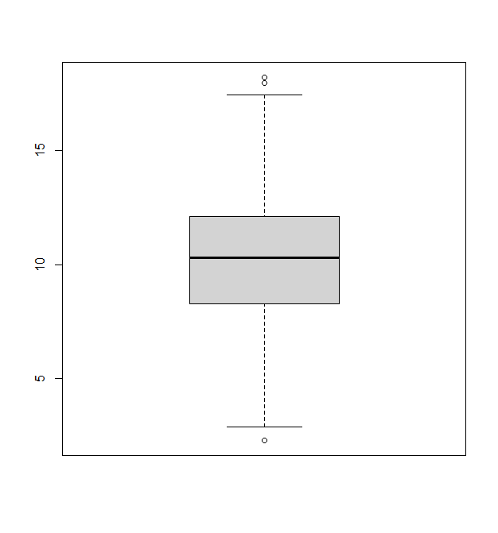
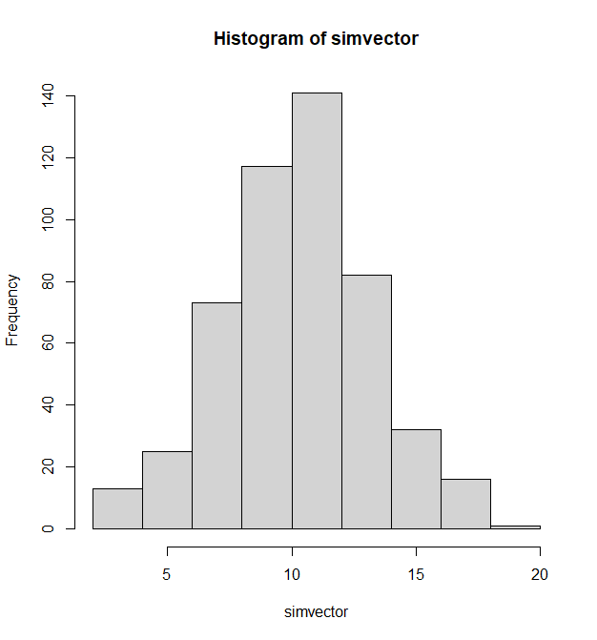
2.

hist(simvector)
boxplot(simvector)

summary(simvector)
Min. 1st Qu. Median Mean 3rd Qu. Max.
2.254 8.285 10.307 10.247 12.087 18.242

2b) IQR = 3rd quartile – 1st quartile
12.087 – 8.285 = 3.802

2c)
Upper limit= 3rd quartile + (1.5 * IQR)
Lower limit = 1st quartile – (1.5 * IQR)
Therefore.
Upper limit = 12.087 + (1.5 * 3.802) = 17.79
Lower limit = 8.285 – (1.5 *3.802) = 2.582

2d)
The histogram is unimodal, symmetric, as the mean and median are approximately equal. It is also not skewed. There are three outliers according to the boxplot, one low value and two high values.

3.
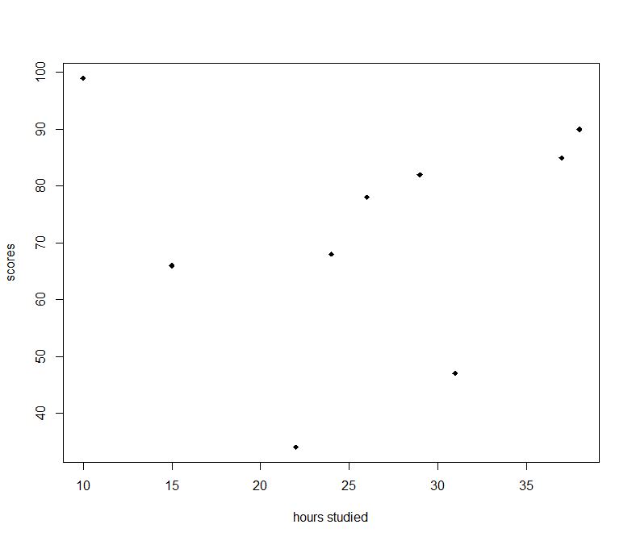
x.values = c(29, 15, 26, 22, 31, 37, 38, 10, 24)
y.values = c(82, 66, 78, 34, 47, 85, 90, 99, 68)
plot(x.values, y.values, pch=18, xlab="hours studied", ylab = "scores")

3b) To compute the sample correlation coefficient for bivariate data, we need to find 5 things:
> mean(y.values)
[1] 72.11111
> sd(y.values)
[1] 20.85332
> mean(x.values)
[1] 25.77778
> sd(x.values)
[1] 9.3244
And n = 9 because we have 9 students

Plugging into sample correlation coefficient equation, which was provided by notes from set 3, we get a total of 0.0374. This implies a positive relationship between the two variables, but we can’t determine a linear association.

3d)
There is also no quadratic, or logarithmic association. So, if the number of hours studied isn’t affecting test scores, then what is? A possible factor could be class attendance. Maybe the students who studied a lot but did poorly didn’t attend class enough, and the students who didn’t study as much but attended classes did well because they attended class. The only thing for certain was that individual hours studied had almost zero impact on test score results.

